**Python Program for simple interest**

Simple interest is calculated by multiplying the daily interest rate by the principal amount by the number of days that elapse between the payments.

**Mathematically,**

Simple Interest = (P x T x R)/100

Where,

P is the principal amount

T is the time and

R is the rate

Example:

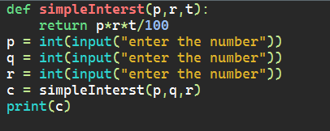

Output:

